|  |  |  |  |  |  |
| --- | --- | --- | --- | --- | --- |
| Date | 8-Dec-22 | | | Tester Name | Andrew McLaughlin |
| Environment | Penfax - Test | | | Login used |  |
| Operating System | Windows | Version: | Update: | | |
| Software Used | Edge | Version: | Update: | | |
| Select Software | Version: | Update: | | |
| Release version | 22.4.1 | | | | |
| Title | M44.01 Pre-Payroll Runs | | | | |
| Test Type | Regression | | | | |
| Test Scenario | M44.01 Pre-Payroll Runs | | | | |
|  |  | | | | |
| Expected Results |  | | | | |
| Pass/Fail | Pass | | | JIRA# | N/A |

Describe your steps with screenshots:

Go to Batches -> Payment Production -> Add Payment Batch

Select all plans except for PEPP/WCB and run a Monthly batch in Test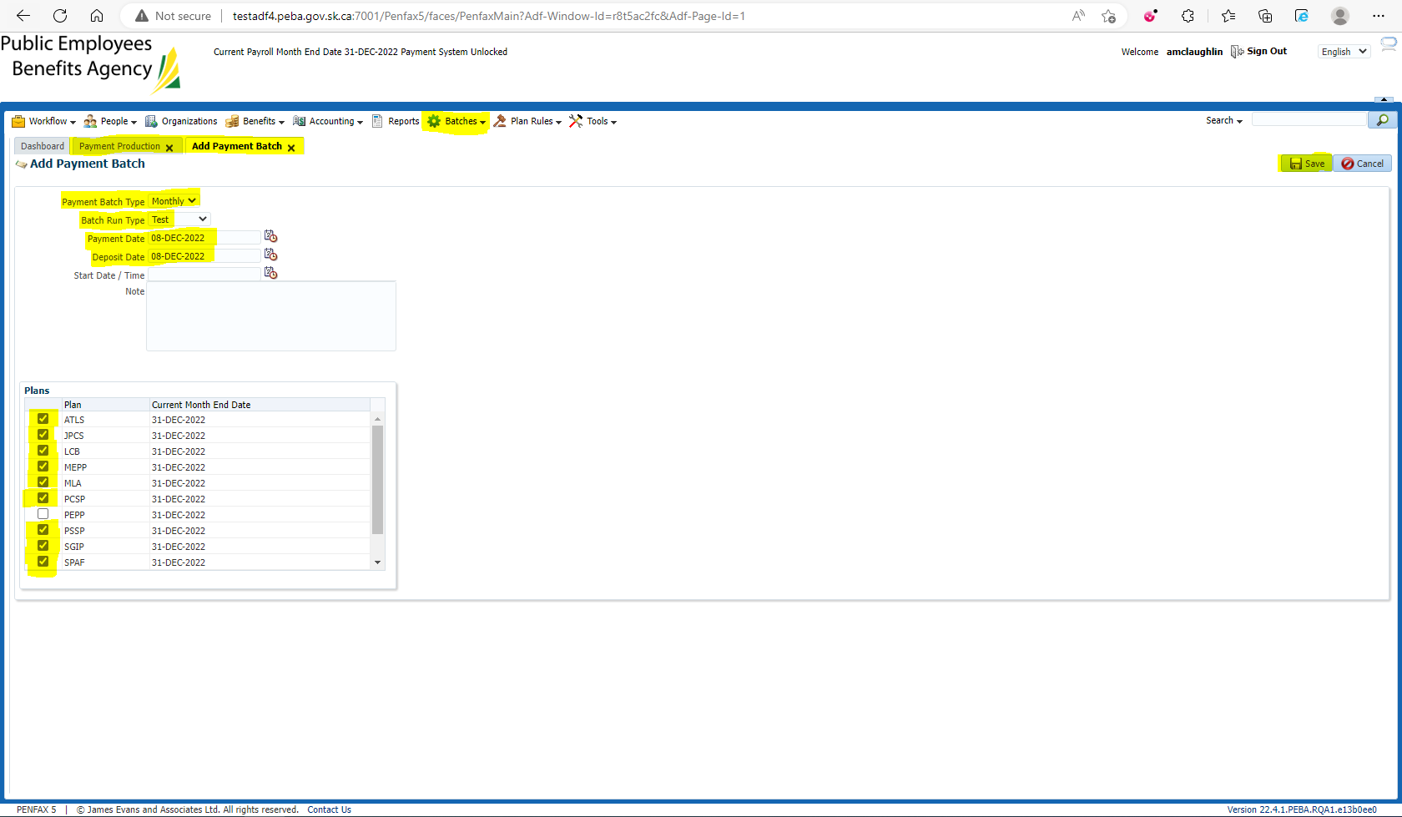

Once the batch has completed successfully, resolve any validation errors there are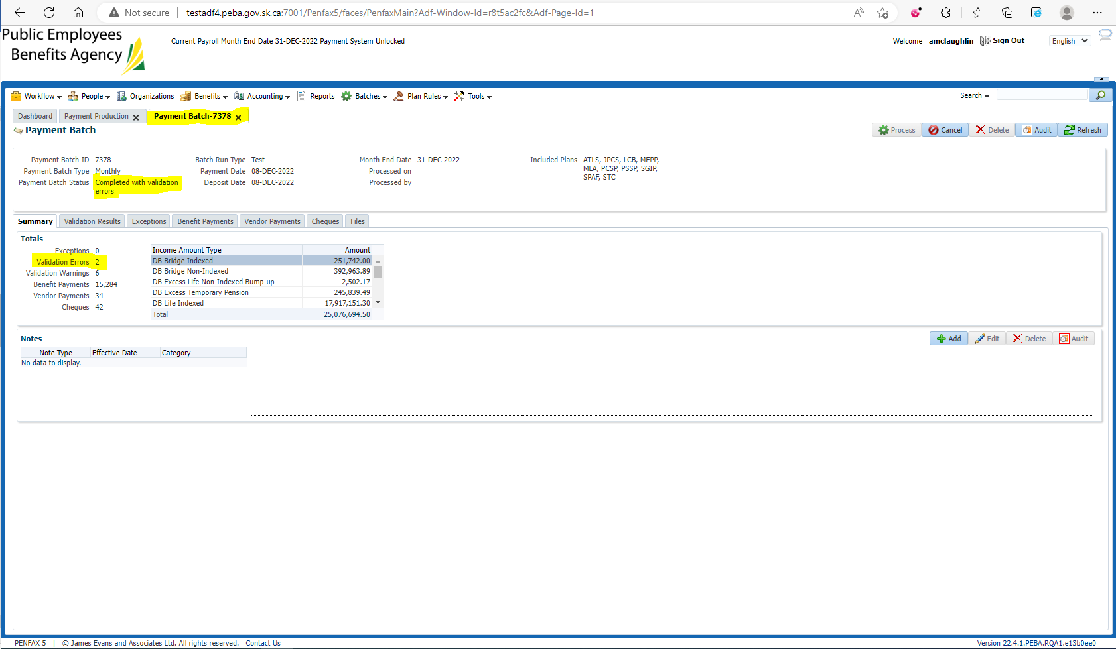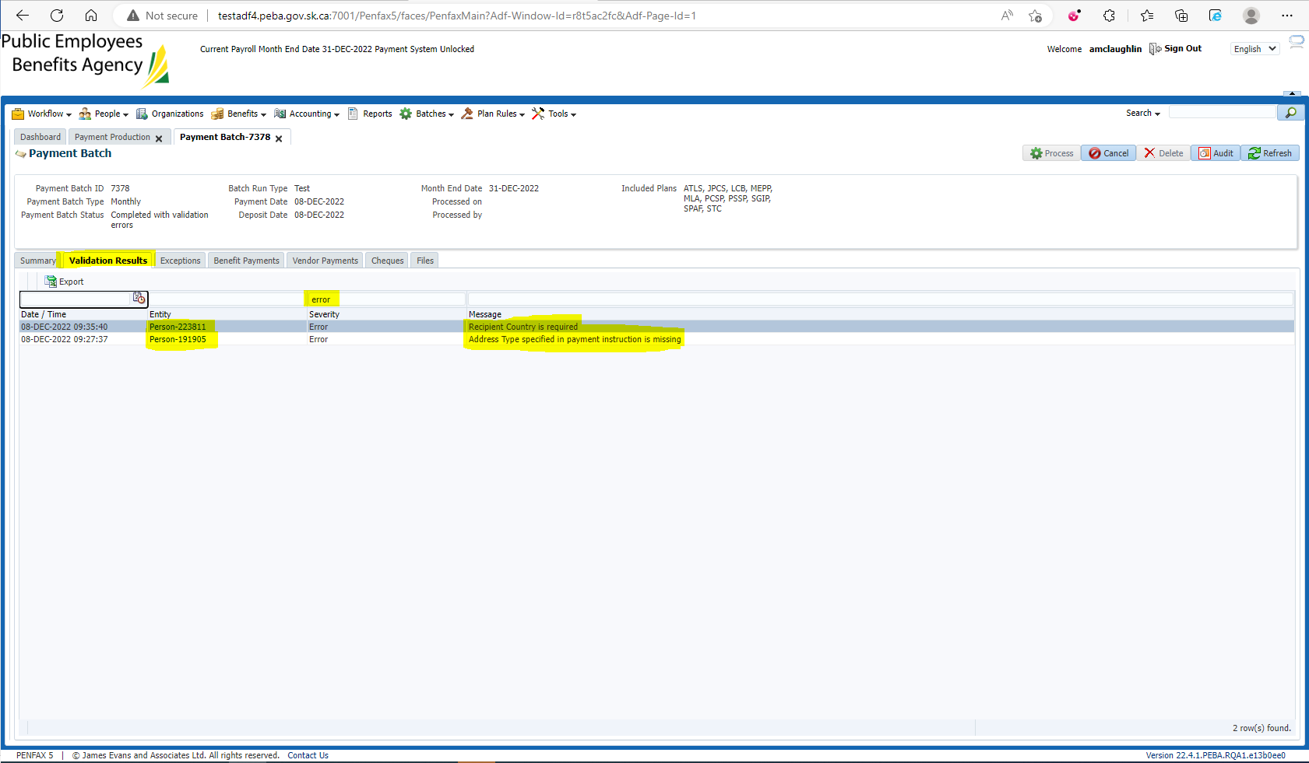

Once the errors have been resolved, run the test batch again to confirm there are no errors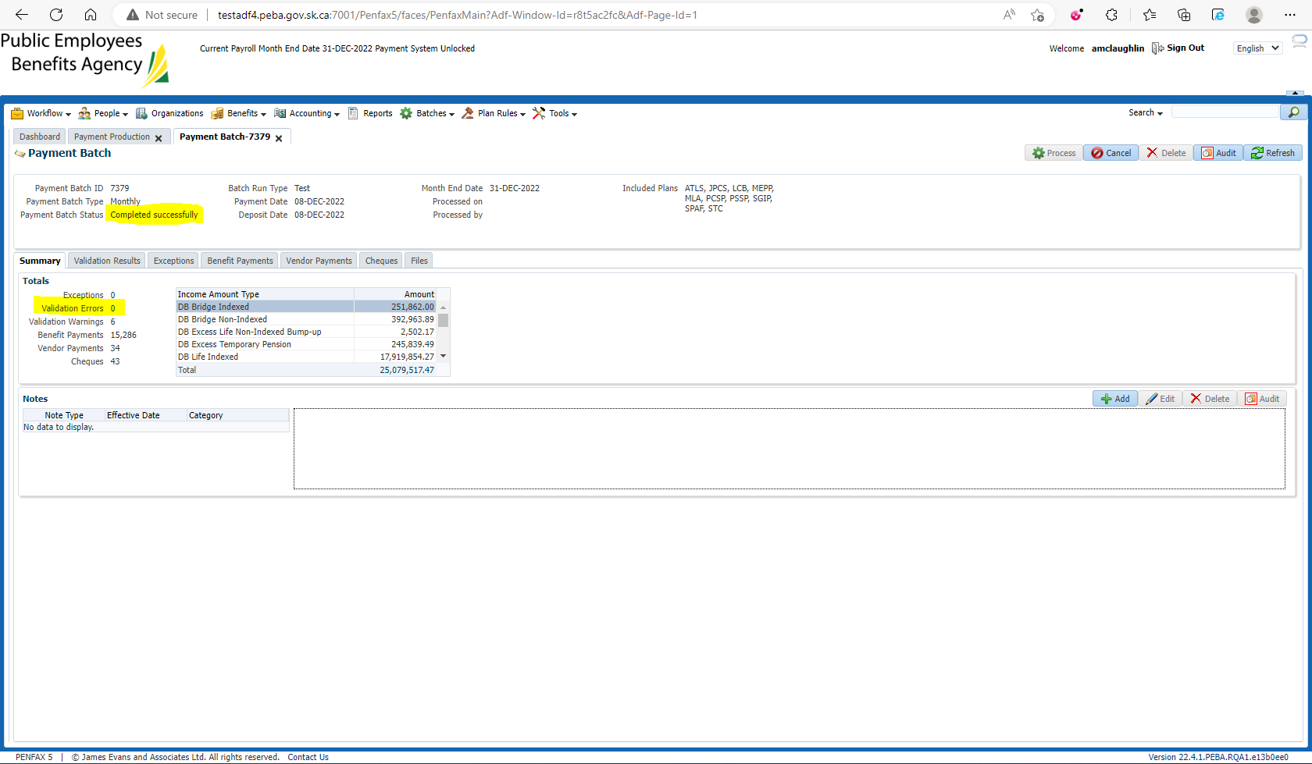

Now that there are no errors, you are ready to run Payroll